Chapter 6: Annual Cash Flow Analysis

6-1
$15
$30
$45
$60
C C C C
C = $15 + $15 (A/G, 10%, 4)
= $15 + $15 (1.381) = $35.72

6-2
B B B B B
$100
$100
B = [$100 + $100 (F/P, 15%, 4)] (A/F, 15%, 5)
= [$100 + $100 (1.749)] (0.1483) = $40.77

6-3
$60
$45
$30
$15
E E E E
E = $60 - $15 (A/G, 12%, 4)
= $60 - $15 (1.359) = $39.62

6-4
D D D D D D
$200
$100
D = [$100 (F/P, 6%, 2) + $200 (F/P, 6%, 4)] (A/F, 6%, 6)
= [$100 (1.124) + $200 (1.262)] (0.1434)
= $52.31

6-5
D D D D
1.5D
$500
$500 = D (F/A, 12%, 3) + 0.5D + D (P/A, 12%, 2)
= D (3.374 + 0.5 + 1.690)

D = $500/5.564
= $89.86

6-6
$40
$30
$20
$10 $10
x
C C C C
x = $40 + $10 (P/A, 10%, 4) + $20 (P/F, 10%, 1) + $10 (P/F, 10%, 2)
= $40 + $10 (3.170) + $20 (0.9091) + $10 (0.8264)
= $98.15

C = $98.15 (A/P, 10%, 4)
= $98.15 (0.3155)
= $30.97

6-7
$40
$30
$20
$10
$20
$30
$40
P
P = $40 (P/A, 10%, 4) - $10 (P/G, 10%, 4) + [$20 (P/A, 10%, 3) + $10
(P/G, 10%, 3)] (P/F, 10%, 4
= $40 (3.170) - $10 (4.378) + [$20 (2.487) + $10 (2.329)] (0.6830)
= $132.90

A = $132.90 (A/P, 10%, 7)
= $132.90 (0.2054)
= $27.30

6-8
………….
n = ∞
$100
$200
$300
$200
$100
$200
$300
$200
A
Pattern repeats infinitely
There is a repeating series:; 100 – 200 – 300 – 200. Solving this series for A gives us the A for the infinite series.

A = $100 + [$100 (P/F, 10%, 2) + $200 (P/F, 10%, 3)
+ $100 (P/F, 10%, 4)] (A/P, 10%, 4)
= $100 + [$100 (0.8254) + $200 (0.7513) + $100 (0.6830)] (0.3155)
= $100 + [$301.20] (0.3155)
= $195.03

6-9
$100
A A A
A = $100 (A/P, 3.5%, 3)
= $100 (0.3569)
= $35.69

6-10
EUAC = $60,000 (0.10) + $3,000 + $1,000 (P/F, 10%, 1) (A/P, 10%, 4)
= $6,000 + $3,000 + $1,000 (0.9091) (0.3155)
= $9,287

This is the relatively unusual situation where Cost = Salvage Value. In this situation the annual capital recovery cost equals interest on the investment. If anyone doubts this, they should compute:

$60,000 (A/P, 10%, 4) - $60,000 (A/F, 10%, 2).

This equals P*i = $60,000 (0.10) = $6,000.

6-11
Prospective Cash Flow:
Year | Cash Flow
0 | -$30,000
1-8 | +A
8 | +$35,000

EUAC = EUAB

$30,000 (A/P, 15%, 8) = A + $35,000 (A/F, 15%, 8)
$30,000 (0.2229) = A + $35,000 (0.0729)
$6,687 = A + $2,551.50

A = $4,135.50

6-12
$600
$700
$800
$900
$1,000
$900
$800
$700
$600
$500
A = ?

This problem is much harder than it looks!

EUAC = {$600 (P/A, 8%, 5) + $100 (P/G, 8%, 5) + [$900 (P/A, 8%, 5) –
$100 (P/G, 8%, 5)][(P/F, 8%, 5)]}{(A/P, 8%, 10)}
= {$600 (3.993) + $100 (7.372) + [$900 (3.993) - $100
(7.372)][0.6806]}{0.1490}
= $756.49

6-13
EUAC = $30,000 (A/P, 8%, 8) - $1,000 - $40,000 (A/F, 8%, 8)
= $30,000 (0.1740) - $1,000 - $40,000 (0.0940)
= $460

The equipment has an annual cost that is $460 greater than the benefits. The equipment purchase did not turn out to be desirable.

6-14
………...
$1,000,000
n = (65–22)12 = 516
i = 1.5% per month
A = ?
The 1.5% interest table does not contain n = 516. The problem must be segmented to use the 1.5% table.
………...
F
n = 480
i = 1.5% per month
A = ?
Compute the future value F of a series of A’s for 480 interest periods.
F = A (F/A, 1.5%, 480) = A (84,579) = 84,579 A

Then substitute 84,579 A for the first 480 interest periods and solve for A.
84,579 A (F/P, 1.5%, 36) + A (F/A, 1.5%, 36) = $1,000,000
84,579 A (1.709) + A (42.276) = $1,000,000

A = $6.92 monthly investment

6-15
……………
A
A
i = 7%
n = 10
i = 5%
n = ∞
P’ = PW of the infinite series of scholarships after year 10

P’ = A/I = A/0.05

$30,000 = PW of all future scholarships
= A (P/A, 7%, 10) + P’(P/F, 7%, 10)
= A (7.024) + A(0.5083/0.05)

A = $30,000/17.190
= $1,745.20

6-16
$20,000
A A A A A A A A A A
$4,000
n = 10 semiannual periods
i = 4% per period
First, compute A:

A = ($20,000 - $4,000) (A/P, 4%, 10) + $4,000 (0.04)
= $16,000 (0.1233) + $160
= $2,132.80 per semiannual period

Now, compute the equivalent uniform annual cost:

EUAC = A (F/A, i%, n)
= $2,132.80 (F/A, 4%, 2)
= $2,132.80 (2.040)
= $4,350.91

6-17
…..
…...
n = 480
A
n = 20
A
F = $1,000,000

F = A (F/A, 1.25%, 480) (F/P, 1.25%, 20) + A (F/A, 1.25%, 20)
= A [(31,017) (1.282) + 22.6]
= A (39,786)

A = $1,000,000/39,786
= $25.13

6-18
(a) EUAC = $6,000 (A/P, 8%, 30) + $3,000 (labor) + $200 (material)
- 500 bales ($2.30/bale) – 12 ($200/mo trucker)
= $182.80

Therefore, bailer is not economical.

(b) The need to recycle materials is an important intangible consideration. While the project does not meet the 8% interest rate criterion, it would be economically justified at a 4% interest rate. The bailer probably should be installed.

6-19
$1,000 / yr
$1,500 / yr
$3,500
$3,500
P
1 2 3 4 5 6 7 8 9 10
P = $1,000 (P/A, 6%, 5) + $3,500 (P/F, 6%, 4)
+ $1,500 (P/A, 6%, 5) (P/F, 6%, 5) + $3,500 (P/F, 6%, 8)
= $1,000 (4.212) + $3,500 (0.7921) + $1,500 (4.212) (0.7473)
+ $3,500 (0.6274)
= $4,212 + $2,772 + $4,721 + $2,196
= $13,901

Equivalent Uniform Annual Amount = $13,901 (A/P, 6%, 10) = $1,889

6-20
A = F[(e^{r} – 1)/(e^{rn} – 1)]
= $5 x 10⁶ [(e^{0.15} – 1)/(e^{(0.15)(40)} – 1)]
= $5 x 10⁶ [0.161834/402.42879]
= $2,011

6-21
(a) EUAC = $2,500 + $5,000 (A/F, 8%, 4)
= $2,500 + $5,000 (0.2219)
= $3,609.50

(b) P = A/i
= $3,609.50/0.08
= $45,119

6-22
(a) EUAC = $5,000 + $35,000 (A/P, 6%, 20)
= $5,000 + $35,000 (0.0872)
= $8,052

(b) Since the EUAC of the new pipeline is less than the $5,000 annual cost of the existing pipeline, it should be constructed.

6-23
Given:
P = -$150,000
A = -$2,500
F₄ = -$20,000
F₅ = -$45,000
F₈ = -$10,000
F₁₀ = +$30,000

EUAC = $150,000(A/P, 5%, 10) + $2,500 + $20,000(P/F, 5%, 4)(A/P, 5%, 10)
+ $45,000(P/F, 5%, 5)(A/P, 5%, 10)
+ $10,000(P/F, 5%, 8) (A/P, 5%, 10) - $30,000 (A/F, 5%, 10)
= $19,425 + $2,500 + $2,121 + $4,566 + $876 - $2,385
= $27,113

6-24
i_{month} = (1 + (0.1075/52))⁴ – 1 = 0.008295

P = 0.9 ($178,000) = $160,200

A = P [(i (1 + i)^{n})/((1 + i)^{n} – 1)]
= $160,200 [(0.008295 (1.008295)³⁰⁰)/((1.008295)³⁰⁰ – 1)]
= $1,450.55

6-25
May 1 Jun 1 Jul 1 Aug 1 Sep 1 Oct 1 Nov 1 Dec 1 Jan 1 Feb 1 Mar 1 Apr 1
$425$425
Equivalent total taxes if all were paid on April 1st:

= $425 + $425 (F/P, ¾%, 4)
= $425 + $425 (1.030)
= $862.75

Equivalent uniform monthly payment:

= $862.75 (A/P, ¾%, 12)
= $862.75 (0.0800)
= $69.02

Therefore the monthly deposit is $69.02.

Amount to deposit September 1:
= Future worth of 5 months deposits (May – Sep)
= $69.02 (F/A, ¾%, 5)
= $69.02 (5.075)
= $350.28

Notes:
1. The fact that the tax payments are for the fiscal year, July 1
Through June 30, does not affect the computations.
2. Quarterly interest payments to the savings account could
have an impact on the solution, but they do not in this
problem.
3. The solution may be verified by computing the amount in the
savings account on Dec. 1 just before making the payment
(about $560.03) and the amount on April 1 after making that
payment ($0).

6-26
Compute equivalent uniform monthly cost for each alternative.

(a) Purchase for cash

Equivalent Uniform Monthly Cost = ($13,000 - $4,000) (A/P, 1%, 36) +
$4,000 (0.01)
= $338.80

(b) Lease at a monthly cost = $350.00

(c) Lease with repurchase option = $360.00 - $500 (A/F, 1%, 36)
= $348.40

Alternative (a) has the least equivalent monthly cost, but non-monetary considerations might affect the decision.

6-27
………
A = $44
$2,600
F
A =$ 84
n = ?
i = 1%
Compute the equivalent future sum for the $2,600 and the four $44 payments at F.

F = $2,600 (F/P, 1%, 4) - $44 (F/A, 1%, 4)
= $2,600 (1.041) - $44 (4.060) = $2,527.96
This is the amount of money still owed at the end of the four months. Now solve for the unknown n.

$2,527.96 = $84 (P/A, 1%, n)

(P/A, 1%, n) = $2,572.96/$84 = 30.09

From the 1% interest table n is almost exactly 36. Thus 36 payments of $84 will be required.

6-28
Original Loan

Annual Payment = $80,000 (A/P, 10%, 25) = $8,816
Balance due at end of 10 years:

Method 1: Balance = $8,816 (P/A, 10%, 15) = $67,054
Method 2: The payments would repay:
= $8,816 (P/A, 10%, 10) = $54,170
making the unpaid loan at Year 0:
= $80,000 - $54,170 = $25,830
At year 10 this becomes:
= $25,830 (F/P, 10%, 10) = $67,000

Note: The difference is due to four place accuracy in the compound interest tables. The exact answer is $67,035.80

New Loan

(Using $67,000 as the existing loan)
Amount = $67,000 + 2% ($67,000) + $1,000 = $69,340
New Pmt. = $69,340 (A/P, 9%, 15) = $69,340 (0.1241) = $8,605

New payment < Old payment, therefore refinancing is desirable.

6-29
Provide Autos
P = $18,000 | F = $7,000 | A = $600/yr + 0.075/km | n = 4 years

Pay Salesmen
0.1875 x where x = km driven

0.1875 x = ($18,000 - $7,000)(A/P, 10%, 4) + $7,000(0.10) + $600 + $0.075 x

0.1125 x = ($11,000) (0.3155) + $700 + $600
= $4,770

Kilometres Driven (x) = 4,770 / 0.1125 = 42,400

6-30
A diagram is essential to properly see the timing of the 11 deposits:

-1 0 1 2 3 4 5 6 7 8 9 10 11
$500,000
P
These are beginning of period deposits, so the compound interest factors must be adjusted for this situation.

P_{now-1} = $500,000 (P/F, 1%, 12) = $500,000 (0.8874) = $443,700
A = P_{now-1} (A/P, 1%, 11) = $443,700 (0.0951) = $42,196

Quarterly beginning of period deposit = $42,196

6-31
New Machine
EUAC = $3,700 (A/P, 8%, 4) - $500 - $200
= $3,700 (0.3019) - $700
= $417.03

Existing Machine
EUAC = $1,000 (A/P, 8%, 4)
= $1,000 (0.3019)
= $301.90

The new machine should not be purchased.

6-32
 | Around the Lake | Under the Lake
First Cost | $75,000 | $125,000
Maintenance | $3,000/yr | $2,000/yr
Annual Power Loss | $7,500/yr | $2,500/yr
Property Taxes | $1,500/yr | $2,500/yr
Salvage Value | $45,000 | $25,000
Useful Life | 15 years | 15 years

Around the Lake
EUAC = $75,000 (A/P, 7%, 15) + $12,000 - $45,000 (A/F, 7%, 15)
= $75,000 (0.1098) + $12,000 - $45,000 (0.0398)
= $18,444

Under the Lake
EUAC = $125,000 (A/P, 7%, 15) + $7,000 - $25,000 (A/F, 7%, 15)
= $125,000 (0.1098) + $7,000 - $25,000 (0.0398)
= $19,730

Go around the lake.

6-33
Engineering Department Estimate
$30
$27
$24
$21
$18
$15
$12
$9
$6
$3
Amounts x 10³
EUAC = $30,000 - $3,000 (A/G, 8%, 10)
= $30,000 - $3,000 (3.871)
= $18,387

Hyro-clean’s offer of $15,000/yr is less costly.

6-34
(a)
…….
$9,000
n = 24
i = 1%
A = ?
A = $9,000 (A/P, 1%, 24)
= $9,000 (0.0471)
= $423.90/month

(b)
$9,000
A’ A’ A’ A’ A’ A’ A’ A’
n = 8 quarterly periods
i = 1 ½% per quarter
Note that interest is compounded quarterly

A’ = $9,000 (A/F, 1.5%, 8)
= $9,000 (0.1186)
= $1,067.40

Monthly Deposit = ½ of A’ = ($1,067.40)/3 = $355.80/mo

- In part (a) Bill Anderson’s monthly payment includes an interest payment on the loan. The sum of his 24 monthly payments will exceed $9,000

In part (b) Doug James’ savings account monthly deposit earns interest for him that helps to accumulate the $9,000. The sum of Doug’s 24 monthly deposits will be less than $9,000.

6-35
Alternative A

$2,000
$500
A A A A A
EUAC = A = [$2,000 + $500 (P/F, 12%, 1)] (A/P, 12%, 5)
= [$2,000 + $500 (0.8929)] (0.2774)
= $678.65

Alternative B

$3,000
A A A A A
EUAC = A = $3,000 (F/P, 12%, 1) (A/F, 12%, 5)
= $3,000 (1.120) (0.1574)
= $528.86

To minimize EUAC, select B.

6-36
With neither input nor output fixed, maximize (EUAB – EUAC)

Continuous compounding capital recovery:

A = P [(e^{rn} (e^{r} – 1))/(e^{rn} – 1)]

For r = 0.15 and n = 5,

[(e^{rn} (e^{r} – 1))/(e^{rn} – 1)] = [(e^{(0.15)(5)} (e^{0.15} – 1))/(e^{(0.15)(5)} – 1)]
= 0.30672

Alternative A
EUAB – EUAC = $845 - $3,000 (0.30672) = -$75.16

Alternative B
EUAB – EUAC = $1,400 - $5,000 (0.30672) = -$133.60

To maximize (EUAB – EUAC) choose alternative A, (less negative value).

6-37
Machine X
EUAC = $5,000 (A/P, 8%, 5)
= $5,000 (0.2505)
= $1,252

Machine Y
EUAC = ($8,000 - $2,000) (A/P, 8%, 12) + $2,000 (0.08) + $150
= $1,106

Select Machine Y.

6-38
Annual Cost of Diesel Fuel = [$50,000km/(35 km/l)] x $0.48/l = $685.71
Annual Cost of Gasoline = [$50,000km/(28 km/l)] x $0.51/l = $910.71

EUAC_{diesel} = ($13,000 - $2,000) (A/P, 6%, 4) + $2,000 (0.06)
+ $685.71 fuel + $300 repairs + $500 insurance
= $11,000 (0.2886) + $120 + $1,485.71
= $4,780.31

EUAC_{gasoline} = ($12,000 - $3,000) (A/P, 6%, 3) + $3,000 (0.06)
+ $910.71 fuel + $200 repairs + $500 insurance
= $5,157.61

The diesel taxi is more economical.

6-39
Machine A
EUAC = $1,000 + P_{i}
= $1,000 + $10,000 (A/P, 10%, 4) - $10,000 (A/F, 10%, 4)
= $1,000 + $1,000
= $2,000

Machine B
EUAC = ($20,000 - $10,000) (A/P, 10%, 10) + $10,000 (0.10)
= $1,627 + $1,000
= $2,627

Choose Machine A.

6-40
It is important to note that the customary “identical replacement” assumption is not applicable here.

Alternative A
EUAB – EUAC = $15 - $50 (A/P, 15%, 10) = $15 - $50 (0.1993)
= +$5.04

Alternative B
EUAB – EUAC = $60 (P/A, 15%, 5) (A/P, 15%, 10) - $180 (A/P, 15%, 10)
= +$4.21

Choose A.

Check solution using NPW:

Alternative A
NPW = $15 (P/A, 15%, 10) - $50 = +$25.28

Alternative B
NPW = $60 (P/A, 15%, 5) - $180 = +$21.12

6-41
Because we may assume identical replacement, we may compare 20 years of B with an infinite life for A by EUAB – EUAC.

Alternative A
EUAB – EUAC (for an inf. period) = $16 - $100 (A/P, 10%, ∞)
= $16 - $100 (0.10)
= +$6.00
Alternative B
EUAB – EUAC (for 20 yr. period) = $24 - $150 (A/P, 10%, 20)
= $24 - $150 (0.1175)
= +$6.38
Choose Alternative B.

6-42
Seven-year analysis period:
Alternative A
EUAB – EUAC = $55 – [$100 + $100 (P/F, 10%, 3)
+ $100 (P/F, 10%, 6)] (A/P, 10%, 7)
= $55 – [$100 + $100 (0.7513) + $100 (0.5645)] (0.2054)
= +$7.43

Alternative B
EUAB – EUAC = $61 – [$150 + $150 (P/F, 10%, 4)] (A/P, 10%, 7)
= $61 – [$150 + $150 (0.683)] (0.2054)
= +$9.15
Choose B.

Note: The analysis period is seven years, hence one cannot compare three years of A vs. four years of B, If one does, the problem is constructed so he will get the wrong answer.

6-43
EUAC_{gas} = (P – S) (A/P, i%, n) + SL + Annual Costs
= ($2,400 - $300 ) (A/P, 10%, 5) + $300 (0.10) + $1,200 + $300
= $2,100 (0.2638) + $30 + $1,500
= $2,084

EUAC_{electr} = ($6,000 - $600) (A/P, 10%, 10) + $600 (0.10) + $750 + $50
= $5,400 (0.1627) + $60 + $800
= $1,739

Select the electric motor.

6-44
EUAC Comparison

Gravity Plan
Initial Investment: = $2.8 million (A/P, 10%, 40)
= $2.8 million (0.1023) = $286,400
Annual Operation and maintenance = $10,000
Annual Cost = $296,400
Pumping Plan
Initial Investment: = $1.4 million (A/P, 10%, 20)
= $1.4 million (0.1023) = $143,200
Additional investment in 10th year:
= $200,000 (P/F, 10%, 10) (A/P, 10%, 40)
= $200,000 (0.3855) (0.1023) = $7,890

Annual Operation and maintenance = $25,000

Power Cost: = $50,000 for 40 years = $50,000

Additional Power Cost in last 30 years:
= $50,000 (F/A, 10%, 30) (A/F, 10%, 40)
= $50,000 (164.494) (0.00226) = $18,590

Annual Cost = $244,680

Select the Pumping Plan.

6-45
Use 20 year analysis period.

Net Present Worth Approach
NPW_{Mas.} = -$250 – ($250 - $10) [(P/F, 6%, 4) + (P/F, 6%, 8) + (P/F, 6%, 12)
+ (P/F, 6%, 16)] + $10 (P/F, 6%, 20) - $20 (P/A, 6%, 20)
= -$250 – $240 [0.7921 + 0.6274 + 0.4970 + 0.3936)
+ $10 (0.3118) - $20 (11.470)
= -$1,031

NPW_{BRK} = -$1,000 - $10 (P/A, 6%, 20) + $100 (P/F, 6%, 20)
= -$1,000 - $10 (11.470) + $100 (0.3118)
= -$1,083

Choose Masonite to save $52 on Present Worth of Cost.

Equivalent Uniform Annual Cost Approach
EUAC_{Mas.} = $20 + $250 (A/P, 6%, 4) - $10 (A/F, 6%, 4)
= $20 + $250 (0.2886) - $10 (0.2286)
= $90
EUAC_{BRK} = $10 + $1,000 (A/P, 6%, 20) - $100 (A/F, 6%, 20)
= $10 + $1,000 (0.872) - $100 (0.0272)
= $94

Choose Masonate to save $4 per year.

6-46
Machine A
EUAB – EUAC = - First Cost (A/P, 12%, 7)
- Maintenance & Operating Costs
+ Annual Benefit + Salvage Value (A/F, 12%, 7)
= -$15,000 (0.2191) - $1,600 + $8,000 + $3,000 (0.0991)
= $3,411
Machine B
EUAB – EUAC = - First Cost (A/P, 12%, 10)
- Maintenance & Operating Costs
+ Annual Benefit + Salvage Value (A/F, 12%, 10)
= -$25,000 (0.1770) - $400 + $13,000 + $6,000 (0.0570)
= $8,517

Choose Machine B to maximize (EUAB – EUAC).

6-47
Machine A
EUAB – EUAC = -$700,000 (A/P, 15%, 10) - $18,000 + $154,000
- $900 (A/G, 15%, 20) + $210,000 (A/F, 15%, 20)
= -$271,660 - $29,000 + $303,000 - $4,024 + $2,050
= $466

Machine B
EUAB – EUAC = -$1,700,000 (A/P, 15%, 20) - $29,000 + $303,000
- $750 (A/F, 15%, 20) + $210,000 (A/F, 15%, 20)
= -$271,660 - $29,000 + $303,000 - $4,024 + $2,050
= $366
Thus, the choice is Machine A but note that there is very little difference between the alternatives.

6-48
Choose alternative with minimum EUAC.
(a) 12 month tire EUAC = $39.95 (A/P, 10%, 1) = $43.95
(b) 24 month tire EUAC = $59.95 (A/P, 10%, 2) = $34.54
(c) 36 month tire EUAC = $69.95 (A/P, 10%, 3) = $28.13
(d) 48 month tire EUAC = $90.00 (A/P, 10%, 4) = $28.40

Buy the 36-month tire.

6-49
Alternative A
EUAB – EUAC = $10 - $100 (A/P, 8%, ∞) = $10 - $100 (0.08)
= +$2.00

Alternative B
EUAB – EUAC = $17.62 - $15 (A/P, 8%, 20) = $17.62 - $150 (0.1019)
= +$2.34

Alternative C
EUAB – EUAC = $55.48 - $200 (A/P, 8%, 5) = $55.48 - $200 (0.2505)
= +$5.38
Select C.

6-50
Payment = PMT (0.75%, 48, -12000) = $298.62
Owed = PV (0.75%, 18, -298.62) = $5,010.60

6-51
Payment = PMT (0.75%, 60, -15000) = $311.38
Owed = PV (0.75%, 48, -311.38) = $12,512.74
She will have to pay $513 more than she receives for the car.

6-52

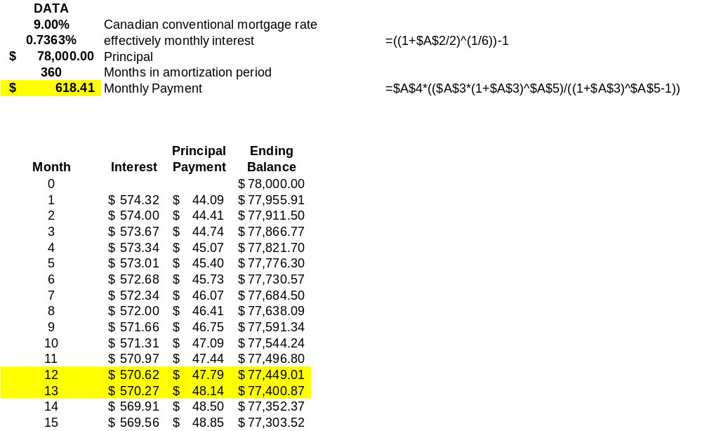

- 618.41
- $77,449.01
- $570.27

6-53
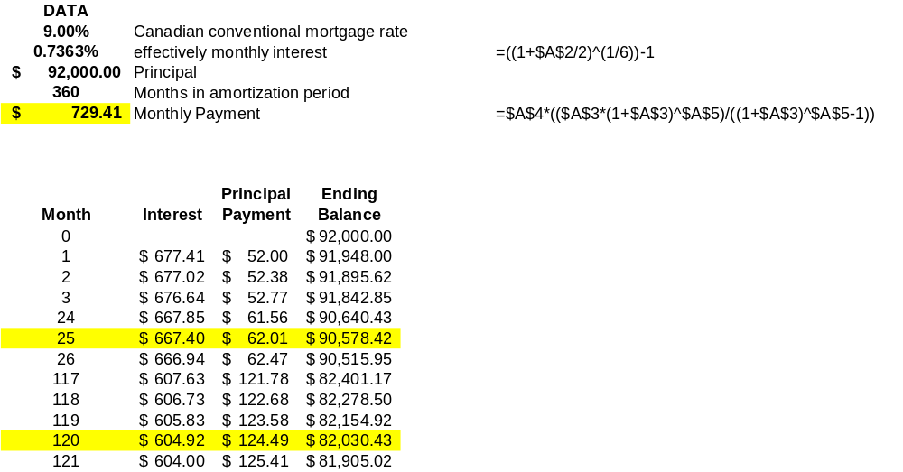

- $729.41

- $82,030.43
- $667.40 / $62.01

6-54
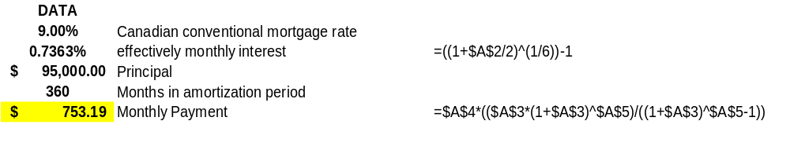
- $753.19

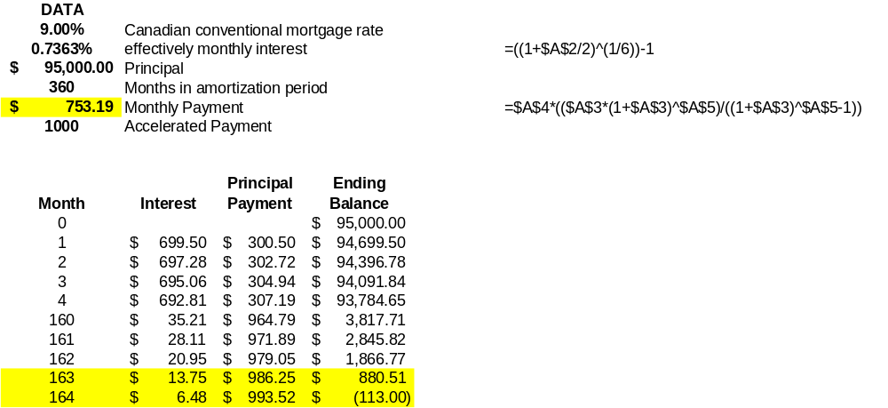

- The mortgage would be paid off after the 164th payment

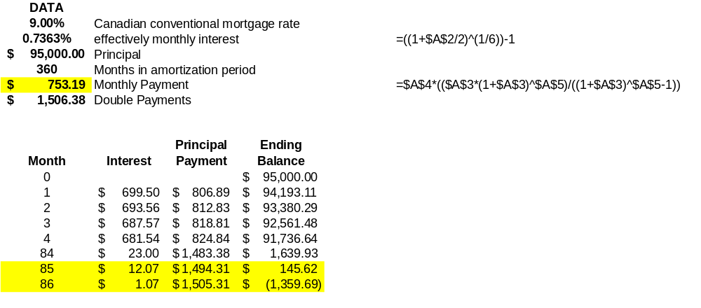

(c) The mortgage would be paid off after the 86th payment

6-55
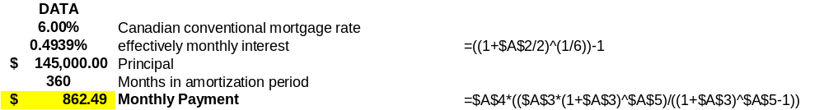

- $862.49

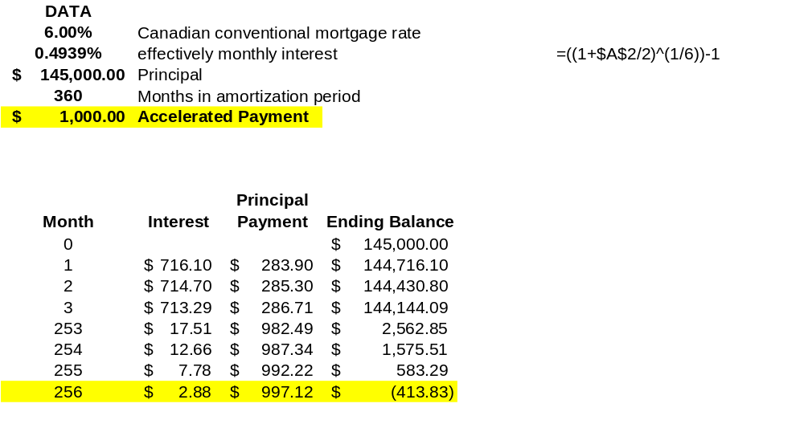
- The mortgage would be paid off after the 256 payment

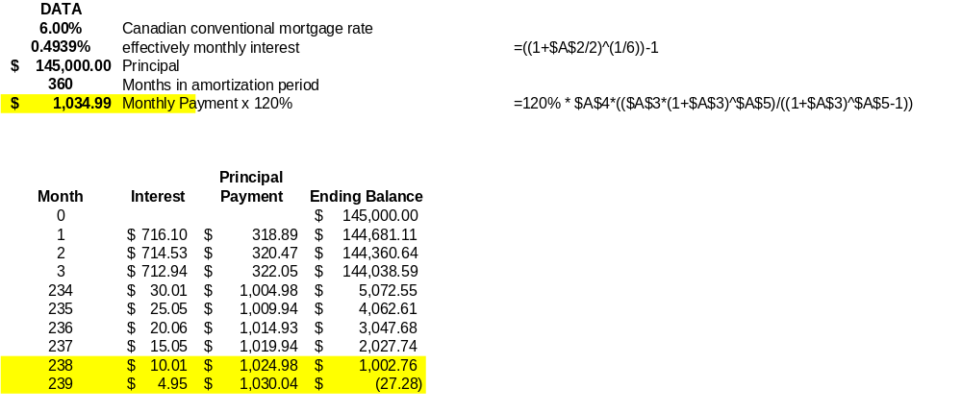

(c) The mortgage would be paid off after the 239 payment

6-56
 | Around the Lake | Under the Lake
2ALTEUAW (modified) | MARR | 7.00%
Length, km | 16 | 5
First Cost/km | $5,000 | $25,000
Maintenance/km/yr | $200 | $400
Yearly power loss/km | $500 | $500
Salvage Value/km | $3,000 | $5,000
Property tax/0.02*first cost/yr | $1,500 | $2,500
USEFUL LIFE | 15 | 15
INITIAL COST | $75,000 | $125,000
ANNUAL COSTS | $12,000 | $7,000
ANNUAL REVENUE | $0 | $0
SALVAGE VALUE | $45,000 | $25,000
EUAB | $0 | $0
EUAC (CR) + EUAC (O&M) | $18,444 | $19,729
EUAW | -$18,444 | -$19,279

Input Data in Shaded Cells Breakeven Analysis

 | Around the Lake | Under the Lake
2ALTEUAW (modified) | MARR | 7.00%
Length, km | 15 | 5
First Cost/km | $5,000 | $23,019
Maintenance/km/yr | $200 | $400
Yearly power loss/km | $500 | $500
Salvage Value/km | $3,000 | $5,000
Property tax/0.02*first cost/yr | $1,500 | $2,302
USEFUL LIFE | 15 | 15
INITIAL COST | $75,000 | $115,095
ANNUAL COSTS | $12,000 | $6,802
ANNUAL REVENUE | $0 | $0
SALVAGE VALUE | $45,000 | $25,000
EUAB | $0 | $0
EUAC (CR) + EUAC (O&M) | $18,444 | $18,444
EUAW | -$18,444 | -$18,444

6-57
Input Data in Shaded Cells

 | Diesel | Gasoline
2ALTEUAW (modified) | MARR | 6.00%
Km per year | 50,000 | 50,000
First Cost | $13,000 | $12,000
Fuel Cost per liter | $0.48 | $0.51
Mileage, km/liter | 35 | 28
Annual Repairs | $300 | $200
Annual Insurance Premium | $500 | $500
USEFUL LIFE | 4 | 3
INITIAL COST | $13,000 | $12,000
ANNUAL COSTS | $1,486 | $1,611
ANNUAL REVENUE | $0 | $0
SALVAGE VALUE | $2,000 | $3,000
EUAB | $0 | $0
EUAC (CR) + EUAC (O&M) | $4,780 | $5,158
EUAW | -$4,780 | -$5,158

Mileage (km)
10,000 | $4,232 | $4,429
20,000 | $4,369 | $4,611
40,000 | $4,643 | $4,976
60,000 | $4,917 | $5,340
80,000 | $5,192 | $5,704

6-58
Input Data in Shaded Cells

 |  | MARR | 8.00%
Current Trucking Cost Per Month |  |  | $200.00
Labor Cost per year |  |  | $3,000
Strapping material cost per bale |  |  | $0.40
Revenue per bale |  |  | $2.30
Bales per year produced |  |  | 500
USEFUL LIFE |  |  | 30
Initial Cost for Bailer |  |  | $6,000
ANNUAL COSTS |  |  | $3,200
Annual Benefits |  |  | $3,550
SALVAGE VALUE |  |  | $0
Salvage value as a reduced Cost
EUAB |  |  | 3,550
EUAC (CR) + EUAC (O%M) |  |  | $3,733
EUAW |  |  | -$183

6-59
Input Data in Shaded Cells

 | MARR | 10.00% | Breakeven
 | Gravity Plan | Pumping | Pumping
USEFUL LIFE | 40 | 40 | 40
COMMON MULTIPLE | 40 | 40 | 40
INITIAL COST | $2,800,000.00 | $1,400,000.00 | $1,400,000.00
ANNUAL COSTS | $10,000.00 | $75,000.00 | $75,000.00
Additional Cost, 10th Year |  | $200,000.00 | $1,541,798.00
Additional Power Cost, yr 11-40 |  | $50,000.00 | $50,000.00
ANNUAL REVENUE | $0.00 | $0.00 | $0.00
SALVAGE VALUE | $0.00 | $0.00 | $0.00
NET ANNUAL CASH FLOW | -$10,000.00 | -$75,000.00 | -$75,000.00
Net Annual Cash Flow (NACF) Method |  |  | Difference
PWB | $0.00 | $0.00 | $0.00 | Drive to zero using solver
PWC | $2,896,765.00 | $2,379,444.00 | $0.00
NPW = PWB – PWC | -$2,896,765.00 | -$2,379,444.00 | -$2,896,765.00
EUAC | $296,222.00 | $243,321.00 | $296,222.00
 | A | B | C
 | NPW | NPW | NPW
 | -2896765 | -2379444 | -2896765
Repeating Cash Flow | -2810000 | -1475000 | -1475000
Year 0 | -10000 | -140000 | -1400000
1 | -10000 | -75000 | -75000
2 | -10000 | -75000 | -75000
3 | -10000 | -75000 | -75000
4 | -10000 | -75000 | -75000
5 | -10000 | -75000 | -75000
6 | -10000 | -75000 | -75000
7 | -10000 | -75000 | -75000
8 | -10000 | -75000 | -75000
9 | -10000 | -75000 | -75000
10 | -10000 | -275000 | -1616798
11 | -10000 | -125000 | -125000
12 | -10000 | -125000 | -125000
13 | -10000 | -125000 | -125000
14 | -10000 | -125000 | -125000
15 | -10000 | -125000 | -125000
16 | -10000 | -125000 | -125000
17 | -10000 | -125000 | -125000
18 | -10000 | -125000 | -125000
19 | -10000 | -125000 | -125000
20 | -10000 | -125000 | -125000
21 | -10000 | -125000 | -125000
22 | -10000 | -125000 | -125000
23 | -10000 | -125000 | -125000
24 | -10000 | -125000 | -125000
25 | -10000 | -125000 | -125000
26 | -10000 | -125000 | -125000
27 | -10000 | -125000 | -125000
28 | -10000 | -125000 | -125000
29 | -10000 | -125000 | -125000
30 | -10000 | -125000 | -125000
31 | -10000 | -125000 | -125000
32 | -10000 | -125000 | -125000
33 | -10000 | -125000 | -125000
34 | -10000 | -125000 | -125000
35 | -10000 | -125000 | -125000
36 | -10000 | -125000 | -125000
37 | -10000 | -125000 | -125000
38 | -10000 | -125000 | -125000
39 | -10000 | -125000 | -125000
40 | -10000 | -125000 | -125000

